**3-3 : Normalization and Business Rules**

Exercise 1: Relational Databases

1. In the table Color row has repeating group of information. To bring the table to first normal form Color row has have additional rows. Then, each name of the color will be presented in separate rows.
2. An attribute must be dependent on its entity’s entire UID. The Supplier ID attribute is dependent not on the current entity and needs to be removed to another entity.
3. Category ID and Category Desc must be removed to another entity to form third normal form.

Exercise 2: Normalize Academic Database ERD

1NF: Exam -- Type needs more than one row.

2NF: Faculty -- First Name, Last Name duplicates, have to be moved.

Faculty -- Full Time, Part Time have to be moved to another entity.

3FN: Faculty -- Login Date, Login Time don’t depend on #ID.

Student -- Eligibility for Exam doesn’t depend on #ID.

Exercise 3: Validate an ERD for Normalization

1. 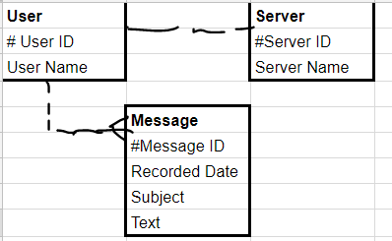
2. The model doesn’t follow the rules of 3FN. The attribute Color Scheme may contain more than one color (=column). Therefore, this attribute needs to be moved to another entity.

Exercise 4: Gather database requirements and Business Rules

